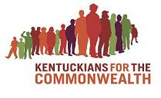**Could YOU be a**

**Citizen Lobbyist?**

Darn right, you could.

Right now, state legislators are gathering in Frankfort and **YOU** can make an impact on the laws they pass – from civil rights, to budget policy to effects on our environment.

And it’s not as hard as you might imagine – picking up the phone to leave a message, writing a letter, or joining a lobby team with Kentuckian For The Commonwealth to talk to a legislator in person.

Learn how at a grassroots citizen lobbyist to make our Commonwealth a little better.

**Thursday, February 7th**

**7:00 p.m.**

**At the Georgetown Public Library**