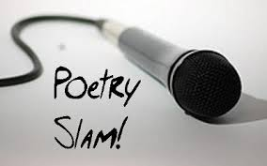

KFTC / NAACP

Present

Poetry SLAM CONTEST

TOPIC: Social Justice

WhERE: Basement of Shelby Co. Public Library- Enter from Washington St

309 8th St.

Shelbyville, KY

When: Monday, October 27th, at 6:00 pm

Open to: Ages 21 and Under

Sponsored by: Shelby Chapters of KFTC (Kentuckians for the Commonwealth) and NAACP (National Association for the Advancement of Colored People)

Prizes: 1st Prize: $100.00

2nd Prize: $50.00

3rd Prize: $25.00

QUESTIONS: (502) 541-2457 or (502) 321-6896

MORE INFORMATION/RULES ON BACK

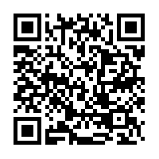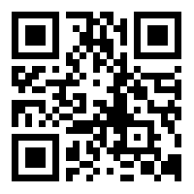 <https://www.facebook.com/events/694740980575084/?ref_dashboard_filter=upcoming>

What is poetry slam?

Simply put, poetry slam is the competitive art of performance poetry. It puts a dual emphasis on writing and performance, encouraging poets to focus on what they're saying and how they're saying it.

What is a poetry slam?

A poetry slam is a competitive event in which poets perform their work and are judged by members of the audience. Typically, the host or another organizer selects the judges, who are instructed to give numerical scores (on a zero to 10 or one to 10 scale) based on the poets' content and performance.

Who gets to participate?

This poetry slam is open to ages 21 and under.

What are the rules?

Though rules vary from slam to slam, the basic rules are:

* Each poem must be of the poet's own construction;
* Each poet gets **three minutes** (plus a ten-second grace period) to read one poem. If the poet goes over time, points will be deducted from the total score.
* The poet **may not use props, costumes or musical instruments**.
* Of the scores the poet received from the five judges, the high and low scores are dropped and the middle three are added together, giving the poet a total score of 0-30.
* The judges will be members of the audience.