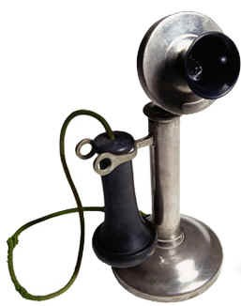
Take Action! - Do you have three minutes to make a call to help pass HB70, our bill to restore voting rights to former felons who have served their debt to society?
1. Call the Legislative Message Line (1-800-372-7181) as soon as you can, and ask to leave a message for some legislators. The line is open 7am to 11pm on weekdays and until 6pm on Fridays. The operator will ask for your name and address.
2. Leave the message for "Senate Leadership, Senate State, Local Government Committee,” and your own Senator (if you don’t know who that is, the operator can tell you).
3. Leave the message: "Please vote yes on House Bill 70."
4. Pass this slip along to a friend and ask them to call. You can also call back yourself and leave a message for other legislators.

Take Action! - Do you have three minutes to make a call to help pass HB70, our bill to restore voting rights to former felons who have served their debt to society?
1. Call the Legislative Message Line (1-800-372-7181) as soon as you can, and ask to leave a message for some legislators. The line is open 7am to 11pm on weekdays and until 6pm on Fridays. The operator will ask for your name and address.
2. Leave the message for "Senate Leadership, Senate State, Local Government Committee,” and your own Senator (if you don’t know who that is, the operator can tell you).
3. Leave the message: "Please vote yes on House Bill 70."
4. Pass this slip along to a friend and ask them to call. You can also call back yourself and leave a message for other legislators.

